Powering Partnerships Towards Innovation Architecture: Skyline 28 has landed!

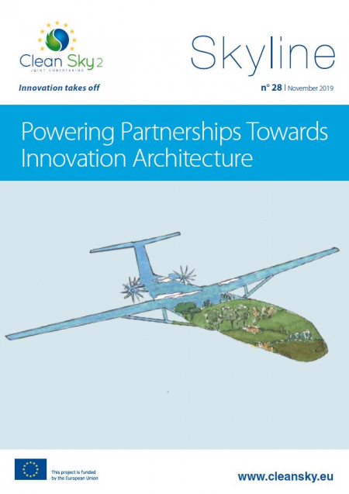

24 October 2019

Skyline 28 has landed! This edition features views from Paul Stein of Rolls-Royce, Henri Werij of TU Delft, and Maxime Hardouin of the SME AeroSpline on what the future of European aviation research could look like, and what this means for the industry’s big players, SMEs and universities.

In parallel to discussions on the future, Clean Sky 2 is still running with full steam ahead! This edition of Skyline includes some key Clean Sky 2 projects which are delivering on our ambitious environmental objectives of reducing CO2 emissions and noise levels from aircraft. You will also get an insight into what the next generation of engineers is working on from the winners of our Clean Sky Academy PhD Award!

Finally, don’t miss the recap of our recent participation at Aerodays and Le Bourget, and mark your calendars for our upcoming events!

Read Skyline 28 [here](https://www.cleansky.eu/sites/default/files/inline-files/Skyline%2028.pdf)